LITERATURE SURVEY ON SMART SIGNS FOR BETTER ROAD SAFETY

A B S T R A C T :

Driver inattention and distraction are recognised as

two of the most critical factors for road safety worldwide. While roadside advertising is often identified as a potential source of distraction, it has received less attention compared to other types of distractions such as texting or calling while driving. Therefore, this study focused on the impact of roadside advertising signs on driver behaviour and road safety. To examine this, a theory-driven systematic literature review was undertaken. In total, 90 unique documents were identified and reviewed using the Task-Capability Interface (TCI) Model to explain the potential safety impact of roadside advertising. The findings confirmed that the TCI model is a useful tool for describing the relationship between roadside advertising and driver behaviour. From this perspective, roadside advertising signs can be considered environmental clutter, which adds additional demands to the driving task. In particular, roadside advertising signs impaired eye movement patterns of drivers.

Additionally, it was demonstrated that the impact of roadside

advertising on driving behaviour is greatly moderated by individual differences among drivers. Of great importance was that young drivers invest more attentional resources in interacting with roadside advertising, which suggests a lower capacity to discriminate between relevant and irrele- vant driving information. Based on the available evidence, however, it is not possible to definitively conclude that there is a direct relationship between the driving behaviour changes

attributed to roadside advertising and road crashes. Nonetheless, while most studies remain inconclusive, there is an emerging trend in the literature suggesting that roadside advertising can increase crash risk, particularly for those signs that have the capacity to frequently change (often referred to as digital billboards). Lastly, it is important to mention that most of the empirical studies undertaken to date feature strong methodological limitations. Consequently, there is an urgent need for more research in this area, given that roadside technology and the transport system are changing rapidly.

1. **Introduction**

Driving as a transport behaviour delivers important social and economic benefits, but also poses significant risks to quality of life, including injury and death. Worldwide, over

1.2 million people die each year as a result of injuries sustained from road crashes (WHO, 2015). Economically, injuries and death that result from road crashes cost governments on average 3% of their gross domestic product (WHO, 2015). Notable improvements in technologies such as cooperative intelligent transport systems and driving automation are

⁎ Corresponding author at: Centre for Accident Research and Road Safety – Queensland (CARRS-Q), Queensland University of Technology (QUT), Brisbane, QLD 4059, Australia.

*1.1. Current study*

Despite the relatively widespread use of roadside advertising, scientific understanding about its impact on task demands is limited. Firstly, the available literature is disorganised and limited compared to other road safety concerns such as mobile phone distracted driving, fatigue, speeding, etc. Secondly, roadside advertising signs are continuing to evolve technologically, creating the

need for ongoing research to address recent technological advancements. For example, over the last 50 years, roadside advertising signs have evolved from static images to incorporate digital displays and changing pictures/videos designed to capture drivers’ attention. Therefore, these technological differences are likely to influence driving task demands in different ways. To close this gap, we conducted a comprehensive systematic literature review informed by the TCI model.

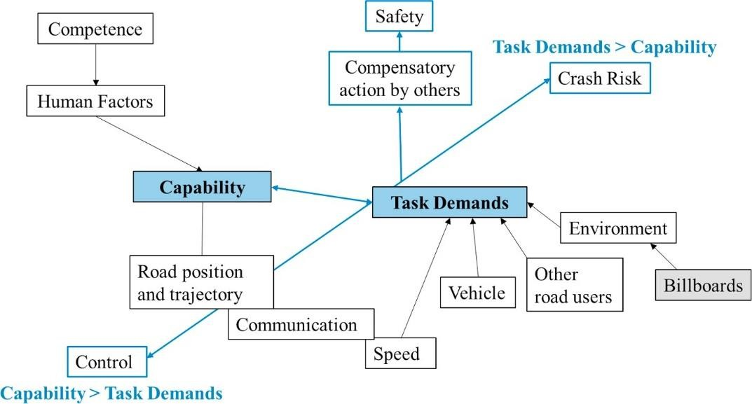

**Fig. 1.** Modification of the task capability interface model.

1. **Method:**

A literature review was selected as the most appropriate method of research to address the question of whether roadside ad- vertising signs impact on driver behaviour and crash risk. Given the number of components and causal mechanisms theoretically described in the TCI model, a systematic classification scheme (SCS) was developed to guide and assist in synthesising the available literature. As described in the introduction, the TCI model proposes that crashes are a result of impaired driver behaviour (i.e., longitudinal and lateral vehicle control including eye movements) which is a function of driving demands exceeding driver cap- ability.

1. *Impacts on driver capability*

A driver’s capability is a function of a plethora of human factor variables, including personal characteristics, physiological characteristics, personal experiences, psychological resources, etc. Although accounting for all these variables would be ideal, the large number of these human factors makes it difficult to study them systematically. Nonetheless, key human factor variables have been explored in relation to roadside advertising signs, as outlined below.

*1.1.1. Age and driving experience*

Age and driver experience are associated with the different outcomes in the interactions between drivers and roadside advertising signs. Research has consistently found that older drivers (generally aged 65 years or older) are negatively impacted by the presence of roadside advertising signs. Edquist et al. (2011) found that older drivers made more lane change errors, particularly in the presence of static roadside advertising signs, than drivers in

other age groups (18–25 or 26–55). This is not surprising since research has sug- gested that age-related medical conditions and declining of functional/cognitive abilities often contribute to higher crash risk amongsenior drivers (Asbridge et al., 2017). Research in traffic psychology has consistently reported that older drivers engaging in sec- ondary tasks while driving are typically more affected than young drivers (Fofanova and Vollrath, 2011).

Teens and young drivers seem to give significantly more attention to roadside advertising. A study conducted by Stavrinos et al. (2016) found that drivers aged 16–19 years give longer glances to roadside advertising signs (digital or static) compared to drivers aged 35+ years. Roadside advertising signs appear to have an effect on the driving performance of young adults, as the age group (16–24) shows a slower reaction time to hazards (Farbry et al., 2001); greater levels of distraction to both digital and static signs (Stavrinos et al., 2016); and self-reported agreement that both static and digital signs create distraction when driving (Sisiopiku et al., 2015). In contrast, other studies have shown no age differences in the detection of static roadside advertisements (Topolšek et al., 2016) or eye glance behaviour in response to static and digital roadside advertising signs (Lee et al., 2004). More research is needed to fully determine the effect of roadside advertising on young drivers.